**Children and Gender Inequality: Evidence from Denmark. Reading note.**

The following research paper explores the effect of childbirth on gender-associated inequality present on the labor market using Danish administrative data. Specifically, this article focuses on the estimation of the "child penalty" – the long-run percentage difference in earnings between men and women that arises due to children. Having estimated "child penalties", authors also focus on the effects of those on labor market decisions of women as well as the dynamic decomposition of gender inequality. Additionally, authors question whether "child penalties" have intergenerational effects. The main insight of this paper comes from decomposition analysis. Authors conclude that unexplained differences in gender-associated earnings, known as “discrimination” in scientific literature, can largely be attributed to women giving birth rather than receiving unequal pay for the same amount of work when compared to men.

*Data*

This research relies on administrative data of the full population of Denmark in the 1980-2013 period. This dataset contains individual-level information on various variables including, but not limited to earnings, labor supply, occupation sector, firms, number of children, and education. Most importantly, the dataset makes it possible to draw connections between workers, firms, members of a family, and generations.

*Theoretical Foundation and Research Findings*

In the literature review section, the authors conclude that current research on the impact of children on women's earnings uses twin birth or sibling sex mix as instruments. These instrumental variables have a certain drawback – it is impossible to quantify the effect of the first child or the total effect of the children on earnings. To overcome this issue, the authors utilize the event study method by comparing differences for mothers and fathers around the birth of their first child. An additional benefit of implementing this analysis is the possibility to analyze dynamic paths of the effects of childbirth because this method relies on individual-level variation. To implement the event study method and estimate the effect of the first child, the authors create a balanced panel of parents with observations starting 5 years before the birth of the first child and lasting 10 years after that. They define the year of the first childbirth as t =0, and index other years with respect to this year. Then, the authors run the following regression:



Where $Y_{ist}^{g}$ is the labor market outcome of interest (earnings, hours worked, wage rates, etc) for individual *i* of gender *g* in year *s* and at event time *t, $α_{j}$* are coefficients on event time dummies, $β_{k}$ are coefficients on age dummies, and $γ_{y}$ are coefficients on year dummies. Omitting event time dummy at t = -1 allows estimating the children impact relative to the year prior to childbirth, while the inclusion of age and year dummies allows controlling for inflations, business cycles, and life-cycle trends. After running the regression, the authors transform estimated effects into percentages $P_{t}^{g}≡{\hat{α}}_{t}^{g}/E[{\tilde{Y}}_{ist}^{g}|t]$, where ${\tilde{Y}}_{ist}^{g}$ is the predicted outcome of interest when all event dummy coefficients are zero. Thus, $P_{t}^{g}$ provides the effect of children as a percent of counterfactual outcome for specific year *t*. Estimations of $P_{t}^{m}$ and $P_{t}^{w}$ allow for a definition of a "child penalty" for women compared to men. More precisely, child penalty in this paper is defined as



Research findings suggest that women experience an immediate child penalty of 30% after childbirth. These differences in earnings tend to shrink to 20% over the period of ten years. Further analysis suggests that child penalties affect hours worked, labor force participation, wage rate as well as the occupational sector and rank of women, while men generally remain unaffected. In order to strengthen their results, the authors run two robustness checks – Difference-in-differences and IV analysis. These checks provide similar results, which strengthens the conclusions of authors. Although the results presented in this paper are robust, the event study method has one potential limitation. Since couples were analyzed over the period of 10 years after the first childbirth, it is possible that some couples ended up having more than one child. In such a scenario, event study methodology would deliver a long-run effect of the total number of children on women's earnings.

Having estimated child penalties, authors turn to dynamic decomposition of gender inequality. This section of the paper aims to separate gender inequality into children-associated and residual inequality. Authors adopt standard Oaxaca-Blinder decomposition but additionally incorporate event study variation by introducing year-specific coefficients for event time ($α_{yj}^{g}$) to the baseline specification. This specification is presented below.

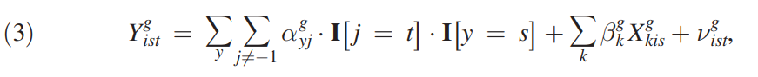

Following the structure of Oaxaca-Blinder decomposition, authors define a mean gender gap in year *s*, $∆_{s}=\left\{E\left[Y_{ist}^{m} | s\right]-E[Y_{ist}^{w}|s]\right\}/\{E[Y_{ist}^{m}|s]\}$ and utilizing new specification, they decompose the gap into “unexplained effects” that result from differences in regression coefficients and “explained effects” that come from differences in observables. This decomposition is shown below.

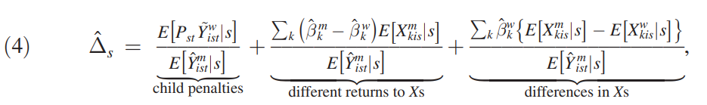

Such decomposition allows drawing a very interesting conclusion. Results indicate that fraction of gender inequality associated with having children has doubled from 40% in 1980 to around 80% in 2013. More precisely, this significant increase can be attributed to a combination of two factors. First, gender inequality associated with children has increased from 18% to 20%. Second, total gender inequality in earnings has decreased from 46% to 24%. In combination, these two factors suggest that most of the gender inequality in earnings today results from women giving birth to children. In other words, uneven distribution of childcare responsibilities drives differences in earnings of males and females.

Lastly, the authors analyzed whether child penalties are transmitted from one generation to the next one. For this reason, they adopted a similar event study analysis but extended the dataset to include years until 1964 to include labor market variables of grandparents of couples that had their first child in the 1985-2003 period. Specifically, this dataset included labor supplies of paternal and maternal grandparents. This information was used to create two distributions of differences in earnings of maternal and paternal grandparents. Higher rank in such distribution would reflect more even gender division of labor in a family. Similar to previous specifications, the authors ran the following regression to estimate the effect of grandparental rank in the distribution on child penalties. The regression below estimates the effect of maternal grandparents

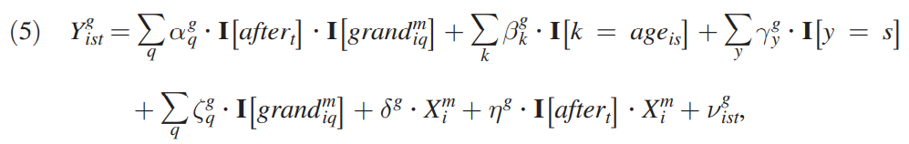

where $I\left[{grand}_{iq}^{m}\right]$ is an indicator for the maternal grandparents being in quantile *q* of the distribution of labor supply, $X_{i}^{m}$ is the vector of control variables of maternal grandparents (education, wealth level, birth cohort, etc) Having run these regressions for paternal and maternal grandparents, authors concluded that there is an inverse relationship between child penalty on women and labor supply of maternal grandmother. In other words, women tend to have smaller child penalties, if they grew up in an environment where the mother worked more compared to the father. The difference in effects of going from the bottom quintile to the top quintile is around 6%. Unlike results for maternal grandparents, paternal grandparents seem to have no effect on female child penalty. Such contrast indicates that child penalties are more likely to be affected by female gender preferences shaped at the time of her childhood than preferences of their male counterparts.

*Concluding Remarks*

In this research paper authors explore the effects of children on gender inequality by utilizing Danish administrative data. As a result of their analysis, the authors arrive at three key takeaways. First, childbirth creates a 20% penalty on earnings of women relative to men in the long run. Second, gender inequality decomposition suggests that most of the gender inequality present in the labor market today is due to children. Third, child penalties have an intergenerational effect on women through maternal grandparents. In other words, women that grew up in "traditional" families tend to have higher child penalties when they have their first child.